The corona virus – what is coming over us here?
Some facts and backgrounds

At the moment we are being quite confronted with a pandemic, postulated by the WHO, of the corona virus, that had its first outburst in China, and now is slowly spreading over Europe an the US. The media almost do not show other news. We are supposed to work from out homes, and are strongly dissuaded (and soon probably even forbidden) to get out. And we are flooded by new infections and as well casualties. All types of gatherings and festivities are postponed or cancelled because of the upcoming virus. Notions that do not make you gay; the fear is well put onto us.
As a result of the limitations on businesses the economy and as well the stock market collapses. Besides this emergency measures are being taken, with packages of what is being called emergency help, with which there is made money free for persons, families and companies.
Different EU countries put up their own measures and close their borders on the own initiative, through which the EU no longer acts as a unity and almost seems to disintegrate.
And the media augment all this and try to make us afraid, even though they deny this. With as a result hoarding up behaviour. The people are scared for themselves.
In short: daily life is affected, out primary civil rights are being limited, and we are not offered the vision how long this may last. We start to get used to this new situation, albeit with some pain, for the prescriptions of behaviour are not being followed everywhere.
And what is this all about? A virus that was recently still unknown (except for some experts), against which the people have not yet build up a resistance. There is eagerly being sought for a medicine, especially a vaccination, but that may last some time, as is being told. In the meantime older medicines against malaria appear to work.
The symptoms of the corona virus sometimes are fever, but mostly complaints of the respiratory tracts: a dry cough, which sometimes is being followed by pneumonia, which may lead to death. But: the cough and the lungs are dry, without moist. Unusual for an infection. It can be transposed by man and animal when these cough.
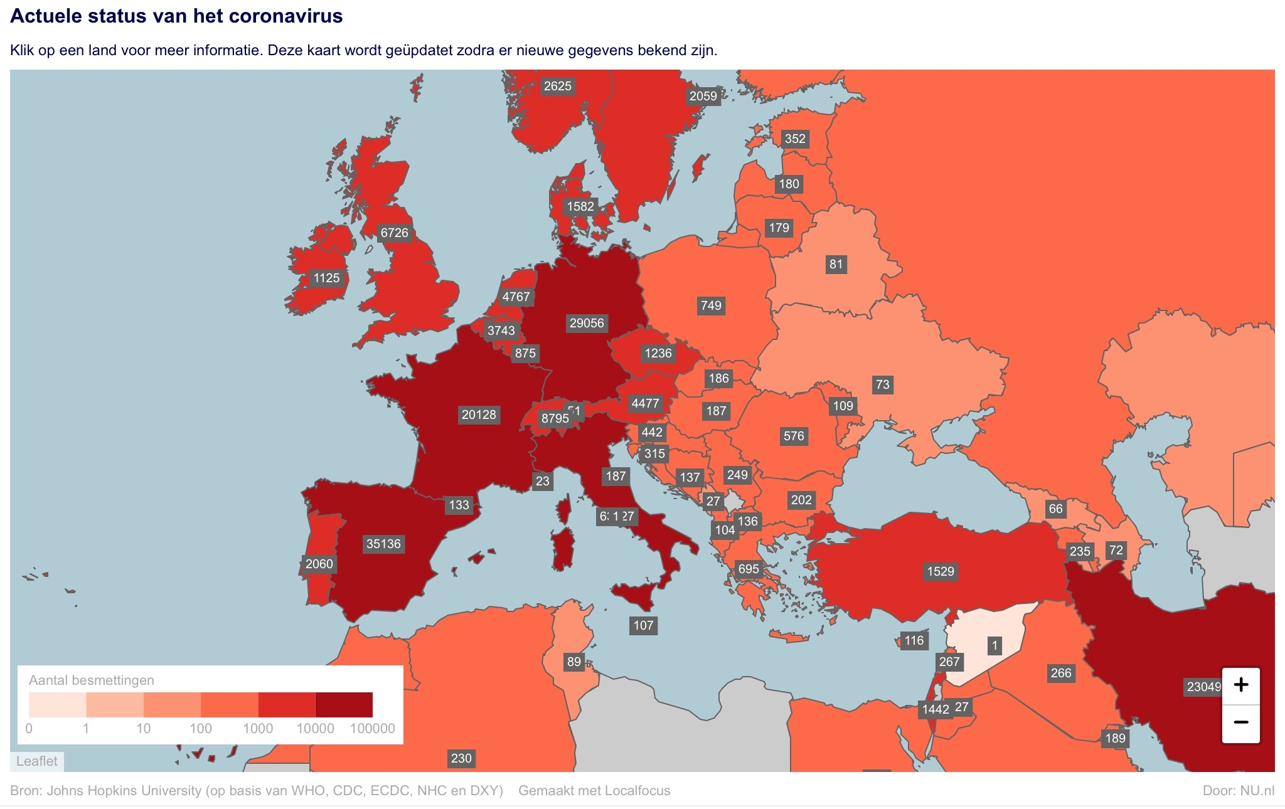
The most important hearths at the moment are Chinese province of Hubei, especially the city of Wuhan, where the hearth of the infection is being suspected; Singapore; South Korea; Iran and some northern provinces of Italy.
The virus in Belgium and Germany is less infective, the effects of it are milder here Also in the Netherlands is the chance of dying much lower than in the hearths mentioned.
With these writings there have been infected 300.000 people worldwide, 13.000 people have died and 93.000 people have been declared healthy again. This is about 1 : 26.000 people on the Earth with an infection, of which 1 : 83.000 people have died, on a world population of about 7,7 billion. About 4,3 % of the infected people have died from it; not even 1: 23. So peanuts. About 99 % of the people that die from the virus are older or have already other complications, just like with an average flu virus. At least, if you may believe the numbers of the media. And quite peculiar: especially in specific regions. Until now there die much less people than with an average flu epidemic, not to speak of the hospital mortalities because of medicines (17.000 each year, about which is not being spoken).

How deep goes the rabbit hole

Let us dive some deeper into the facts. And with this not only consider what the mainstream media present us, but also what is being reported by the alternative press.
-The virus should be fabricated in labs and through animals that were sold in the Wuhan market expanded: specifically horseshoe bats and some African pangolin, which are delicacies for the Chinese kitchen. The US would have send thus upon China.
-Also not-corona related flu and other sicknesses should be taken into the amount of infections and deaths. China is quite inadequate in diagnosing this virus. All unusual cases of illness are being counted in. And these sometimes are completely outside of the infection hearths. In Wuhan people just fall down or even die without indicated infection.
-There should be a connection to 5g internet frequencies.

Some backgrounds from spiritual science

Rudolf Steiner talks about his visions at different sites. According to one of his lectures the pathogens are effects, cast upon the Earth, of the adversaries; elemental beings that have as their purpose to stop us from developing. These adversary forces once have been beaten by Michael and his troops, and were rising up again because of the intellectual culture of his time – which only has grown worse ever since. On another occasion he postulated that pathogens are killed and tortured animals because of our nutritional behaviour that fall back on us. He speaks of bacils, a form of bacteria. For viruses had not yet been discovered by then.
An even more important indication is that electro-smog, which started in his time, can cause infectious diseases, which is a reaction of the body to the adversary forces. After a question about the Spanish flu pandemic in 1918 he answered that pathogens are an excretion of the poisoned cell. It was not yet known by then, but now we know that amongst others DNA and RNA is being excreted (which a virus can close in). He saw electricity as fallen light, and electromagnetism (so radiation) as fallen astrality. This vision helps us to look in the direction of radiation (see underneath).
Thomas Mayer refines this vision based on his own observations: the elemental beings of corona have stayed behind on the preceding phase of Earth’s development, the Old Moon, when the Angels went through their human existence phase. These elementals became the pray for the counter forces ahriman and sorat. They have been placed in a kind of quarantine by the Form Spirits of the Sun. Now they want to connect again to the Earth and explain themselves with man and the Earth, in order to get along with development again. Initially they showed up as fear elemental beings. But by connecting to these in love you can help them further. They are glad when you tell them about Christ as the lord of the Earth, for this is new to them. By making this clear to them they soften. Thomas calls us up to meditate on them, and to further investigation. He also brings the virus in relation to the great conjunction Pluto, Mercury, Saturn and the Sun on the 12th of January.

A distillation of what might be going on behind the scenes

When you dig even deeper, you come in the regions that the media often sarcastically call ‘conspiracy theories’. However there are more things that appear to come together of what is or can be going on. You then come to agenda’s of dark and light forces. I paint some of these.
Concerning the connection between the corona virus en 5g internet: There has been research for years after the effects of electromagnetic radiation (EMR) on organic tissue, so on plant, animal and also man. It appears that with low but enduring exposition EMR, organic tissues treat these with defence mechanisms. And especially moulds and bacteria, and besides as well viruses, feel that the cell tissue reacts, feel attacked and start to excrete poisonous substances as their defence. And viruses start to use the mechanisms of the host-cell to multiply themselves accelerated – a virus is nothing more than a piece of hereditary material, DNA or RNA, that is enveloped by a functional protein cloak– actually nothing more than a biological robot. As a result of this EMR lowers immunity. This goes up for the already known radiation by the internet, from 1 – 4g, and with 5g this is being amplified even more. This radiation runs through 6-600 GHz frequencies. There will be broadcasted in 3 reaches, and one of these is around 60 GHz. This millimetre wave is the frequency of oxygen, through which the electrons in the oxygen in the air, O₂, will resonate and can no longer be well absorbed in the lungs: The haemoglobin of the blood can no longer carry this exalted oxygen. You then suffocate. Remember the symptoms of the virus: amongst others a dry cough and a dry pneumonia. And as well that sometimes without infection people drop down unconscious or even dead. This as well affects the water (in formula H₂O) negatively, which partly consists of oxygen: water is the carrier of life. And what appears? The Chinese city of Wuhan has a very dense network of 5g broadcasters (more than 10.000), which have been placed there in October 2019. So just before the strong virus outburst here. Also the other infection hearths, like the cruise ships (and unfortunately many hospitals), already use these frequencies.
The only country that seems to contradict this, is Iran, But when you dig deeper, here as well appears to be installed a strong 5g network in secret.
Normally you get a wet cough with a flu, wherewith the slime that is being formed, causes that the pathogens will be removed from the lungs. Here the contaminated become quite a dry cough, which does not indicate an infection. And non-infected people at places fall down. Their numbers are taken into the statistics.
According to German investigator Katherine Horton is 5g the cherry on the cake, on which over a hundred years there has been worked behind the scenes by our top layer to enslave the people. In this light is quite remarkable the notion of the Dutch homeland secretary Mona Keizers, who in parliament poses that these frequencies will also be applied for ‘crowd control’. So to stop people from demonstrating with the pain caused by its radiation. How clear do you want it.
There are rumours that the Chinese have stopped selling their products to the world power behind the scenes, concentrated in the US, because they no longer want to be paid in the fake money of the petrodollar without value. As a punishment they begot overloaded with the virus. This is hard to verify, but out of duality-thinking you can imagine something with this.
Concerning the financial situation in the world. The American Federal Reserve an our central banks– all private banks – keep on printing billions of dollars and euro’s and as well buy state loans, which before would have had a positive effect. But the stock markets keep sinking, with some ups and downs. And yet governments keep on proclaiming billions/trillions to support the people and the economy. Where does this come from? Here you come to another story: the battle against the by world elite conducted banks that want to help us to the bitcoin, and another side prepared and on Sunday implemented new money system, called the ‘Quantum Financial System’, that comes in the place of the fiat petrodollar. And this latter is on the winning hand. It is through this that the western governments all of a sudden can come up with large amounts for support: there is an abundance of this money. And during the time of this transition it is important that there will be no false flag attacks or riots are being provoked: the people are safe inside.
You touch here on quite a different story, being that of GESARA, the abbreviation for ‘General Economic Security and Reformation Act’, an international law that has been put up in the previous century by an international group and army that calls itself the ‘Earth Alliance’, and that strives to implement this law. It is based op this new money system that is based on gold, and when implemented, the Earth is free of debt. The money that has been harvested the last centuries (already since the napoleontic wars) by the debt resting upon it, which flows to our elite, is all of a sudden worthless, and this elite looses its power with it. The case is that members of different royal families over the world, like the Chinese emperor family (I mean here members of the elite that did not go along with the corruption), have been digging for centuries (sometimes even millennia) for gold, and as well have become very rich by taxes. This gold is being released and made available with GESARA for the entire world: hence that the so-called ‘help resources’ of our governments probably come from this source. It is only disturbing they do not call it this way. But that might come on its time.
Why did we hear nothing or hardly anything of this? Simply because the preceding presidents of the US kept this as far away from us as possible. In 2000 Bill Clinton was compelled to sign this law. After this followed I 2001 the attacks on the WTC in New York, which gave the world a turn in another direction. At stake here is a battle between the light and dark forces behind the screens, wherewith particularly the last time abuses of top figures comes to the light: politicians, members of royal families, Hollywood stars. This started with the Pizzagate scandal, and had its following-up in the process against Epstein, who had many ‘friends’ at the top.
See also the long-time research of Kevin D. Annett to the abuses within the church and state. You really get sick by reading what has done to us and to our children by this elite.

What if this is all true?

You of course can put many questions to this. I do not want to convince you as my reader. But I do want to try to wake you up to start thinking and feeling with all these data by yourself.
Some other relevant facts. German main bank the Deutsche Bank, which has been the axis for the central banks over the entire world, recently has been written out of the trade register. It could no longer handle the debt burden and penalties. The stock markets strongly swing and tend to collapse. Different CEO’s retreat. Politicians do not want to be re-elected or resign. There have gone out over 500.000 indictments over the world, and soon top figures are being arrested (they started from the lower ranks upward). Suddenly many politicians and Hollywood stars have corona, more than average. According to the sources that I take my information from, these people have been arrested and got house arrest awaiting their process. And they have chosen for calling this the virus infection as its cause.
Recently there have been earthquakes in Utah and Idaho, the US and also in Zagreb, Croatia – none of these are centres of earthquakes. I came across the information that these were attacks against subterranean military bases, where children have been kept prison amongst others. They are being freed and these bases with its underground long tunnels are being destroyed with little nukes. Which causes the earthquakes. This happened as well in 2019 near Lake China in Nevada, de US.
The overall picture that comes up is that of the battle between the dark powers, that even retract their power from Satanism, with all its cruel rituals (a continuation and perfection of Herodes’ child slaughter) against this Earth Alliance, of which its members often are being indicated as ‘white hats’ or ‘white knights’. These latter often posess key positions and have remained sleepers for a long time, to be able to seize at the right moment. You get the image here of the battle between light and darkness: the latter as the physical representative of the counter force that is being called ahriman or satan. It has called to with the corona virus infection deregulate the economy and society, with 5g bind the people to it, and has as one of its purposes to develop a vaccination against the corona virus that should be compelled to be taken. In it should be microchips that can read out and as well alter our DNA. With the help of this 5g network (there are already about 20.000 satellites in a low orbit around the Earth that broadcast in its frequencies). A really sickening perspective. Before it has not succeeded to form a world government (the globalists, or the new world order), as well because he BRICS countries have united and opposed this, with their own monetary system.
And at the other side the Earth Alliance, a broad spectrum of gathered goals and armed forces, with a strong military intelligence, which is winning the battle. They have taken over the coronavirus threat as an initiative, in this way, that the people should stay at home (for their own safety); that the new financial system (QFS) of GESARA can be implemented; and that the criminals within the elite and their helpers of lower rank can be arrested and brought to trial. And imagine for yourself: it must be a strong power that puts down the western world within a couple of weeks, and has the governments dance to their music. Doesn’t this give confidence? And one of their main aims is to give back the power to us, citizens of the world.
With this as the overall picture you maybe can accept the momentarily somewhat limited conditions. Out of the notion that it will pass over, and a much more positive image for the new future may rise up, with a basic income for each human and also the liberation of a corrupt elite that with their fiat money and compelled work wanted to keep us as their slaves.
A perspective that can make you glad inwardly. And with your free time you can start asking yourself what you would really like to do if you had a basic income; what kind of work or occupation? You can devote yourself to your inner development. For as well this – besides it is one of the main reasons why we have come to the Earth – this will strengthen you in your own healing capacities against whatever kind of smog or infection that may threaten you. You thus take your life in your own hands.

What can we do

Considered from the 4 elements:

Earth – behold your circumstances and ask yourself what you really would want to do if everything was possible. And direct yourself to this.

Water – how would you organise your life from now on, also in relation to your own health. To this belongs as well how you like to deal with technique and cell phones. And if you become sick, learn the healing techniques to strengthen your life forces. Such as the Healing Tao with its exercises in the circulation of life energy.

Air – behold your fears that the virus and the threat coming from it may arouse in you, and transform this into love and confidence. Like this you enter the consciousness of the now that is important for our time, the astral consciousness or the 5th dimension. You learn to act out of your heart, that which your conscience tells you from it. With this you can make no ling term planning (which may do your head), but with every occurring situation you can give shape to your life in a meditative way. Therewith you enter a higher state of being than the mere physical one. Directions like mindfulness may help with these. Just to mention one.

Fire – the ego force that you develop by considering further steps and act to this as well (your ego, your spirit germ, is a will-being, which lives and works in the warmth). And thus you strengthen yourself for whatever distractive and sickening influences. Meditation and directive music making may help to this.
I wish all the good within the present circumstances, out of an inner knowing that these will not last very long.

Nicolaas de Jong.

From: Magazine ‘Starwise’ issue nr. 16.

In GA 177.
In GA 266b.
This flu caused millions of casualties. It occurred together with the first word wide application of radio waves.
See the youtube film ‘Dr Thomas Cowan: Virus et électrification de la Terre (English spoken). He indicated hat each epidemic was preceded by a new application of electromagnetic radiation.
See for his newsletter about this his website www.anthroposophische-meditation/de.
See as well my blog about the effects of the first new moon of this year, at Tuesday March 23.
See the research of Dr. Dietrich Klinghardt about this, and as well the clarifying research article about the combination of the corona virus and 5g: https://principia-scientific.org/5g-and-the-wuhan-coronavirus/.
The zinc in the medicines mentioned against malaria hems the RNA-reproduction of the virus in the host-cell.
See this clarifying youtube video of Christina Ashley: https://www.youtube.com/watch?v=feO9FiJ7tZo&feature=youtu.be
See for her research: https://www.youtube.com/embed/HWdoXoCetvE
See for her indications: https://www.earth-matters.nl/11/14727/verborgen-nieuws/staatssecretaris-mona-keizer-openlijk-over-verband-tussen-5g-en-crowd-control.html
See www.gesara.com for the recent developments.
What is called here the ‘elite’ is the group of people at the top of our society. Under these belong many royal houses, with the English house on top. Further on bankers many CEO’s of multinationals, and so-called ‘philantropists’ like George Soros and Bill Gates. And not to forget the pope, one of the top actors. This group is also called the ‘Cabal’. They work through the CFR, trilateral commission and Bilderberg meetings amongst others. They created the ‘Deep State’, the ‘American Inc’, which had control behind the scenes, wit hall these military ‘tour de forces’. And also the extended network of drugs- and child trafficking, for their own energetic consumption. Or the extended programs of mind control. This is now being taken down and comes to the light.
In building 7 of the WTC this law was being signed and reinforced and through it, the farmers should become the owners of their own land, as one of the effects of this law. With the fire in this building and its demolition (Note: this was not one of the two towers, but stood besides) all the people in concern have died and thus the law was stopped.. In 2011 Barack Obama had to make public this law, as he was compelled to do this by a petition. But he never did this.
See the website of his International Tribunal into Crimes of Church and State: www.ITCCS.org
On April 1 president Trump and his team announced a war against drug and human traffic cartels all over the western hemisphere.
Also known as the army of anons, with Q anon as its frontrunner.
See my schooling methods and courses on www.runworkz.com and on www.jaspisschool.eu, which are also online available.
In the US there is being worked by a team of scientists to enfeeble the unhealthy effects of EM radiation, without rejecting 5g and other technical applications. Under covered-up words president Trump calls this ‘The Wall’. This is not only the physical wall at the border with Mexico. And they are now enfeebling the 5g radiation in the US which reinforced the corona effects.
See for example may methods to work with the forces of our four bodies within music: https://www.runeworkz.com/methods/organ-music/.

